**Working with dynamodb**

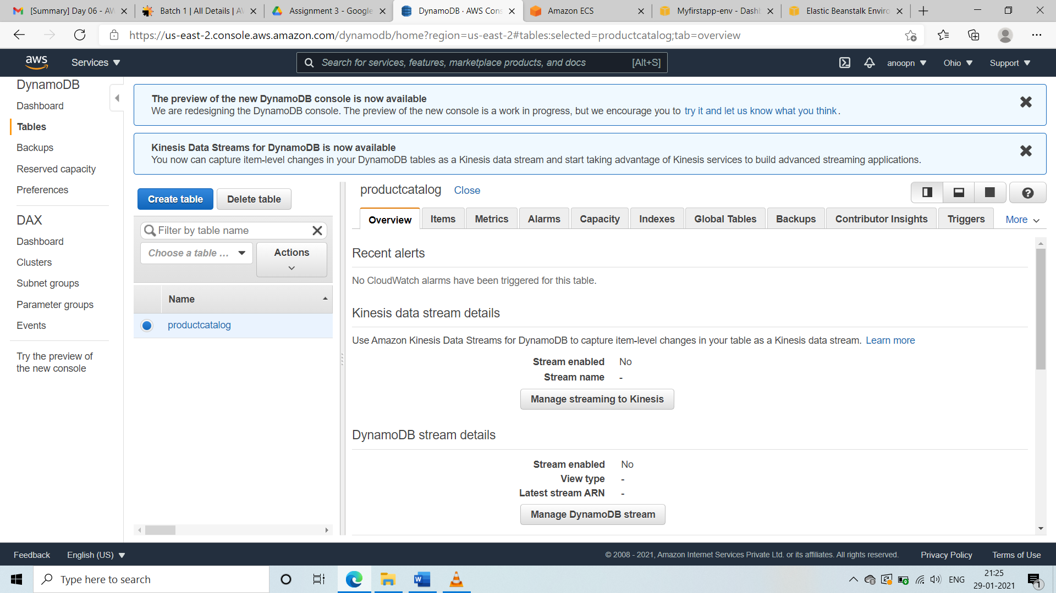

**SS1: ● Create table**

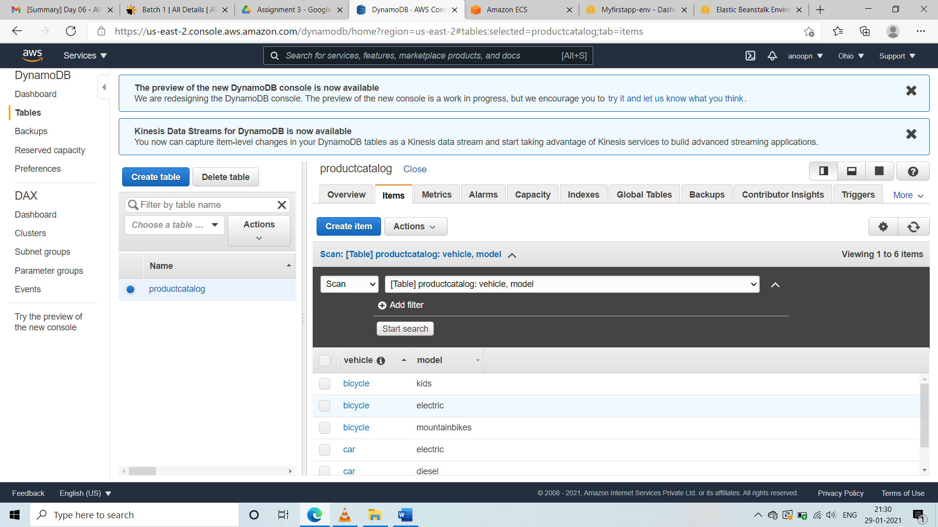

**SS2: ● Add items into the table**

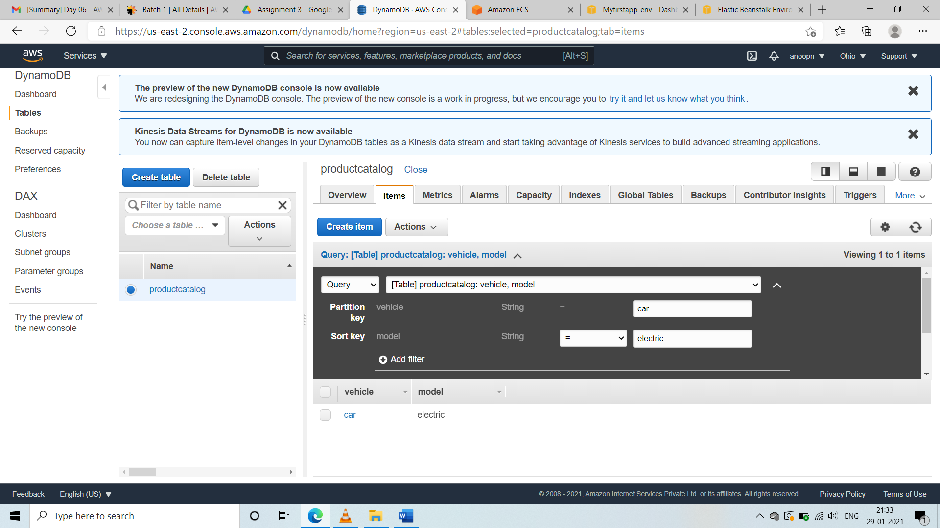

**SS3: ● Execute a query to filter using primary and sort key**